For the Docker commend if we need to install the docker in the base OS like Ubuntu , centOS

* Sudo apt-get install docker -y for ubuntu
* Sudo yum install docker -y for centos

Finally, we need to check the version for docker weather its installed or not

* Docker -v

To know more commend about the docker cml

* Docker 🡪 c=type docker and click enter we will get the over all docker cml list
* 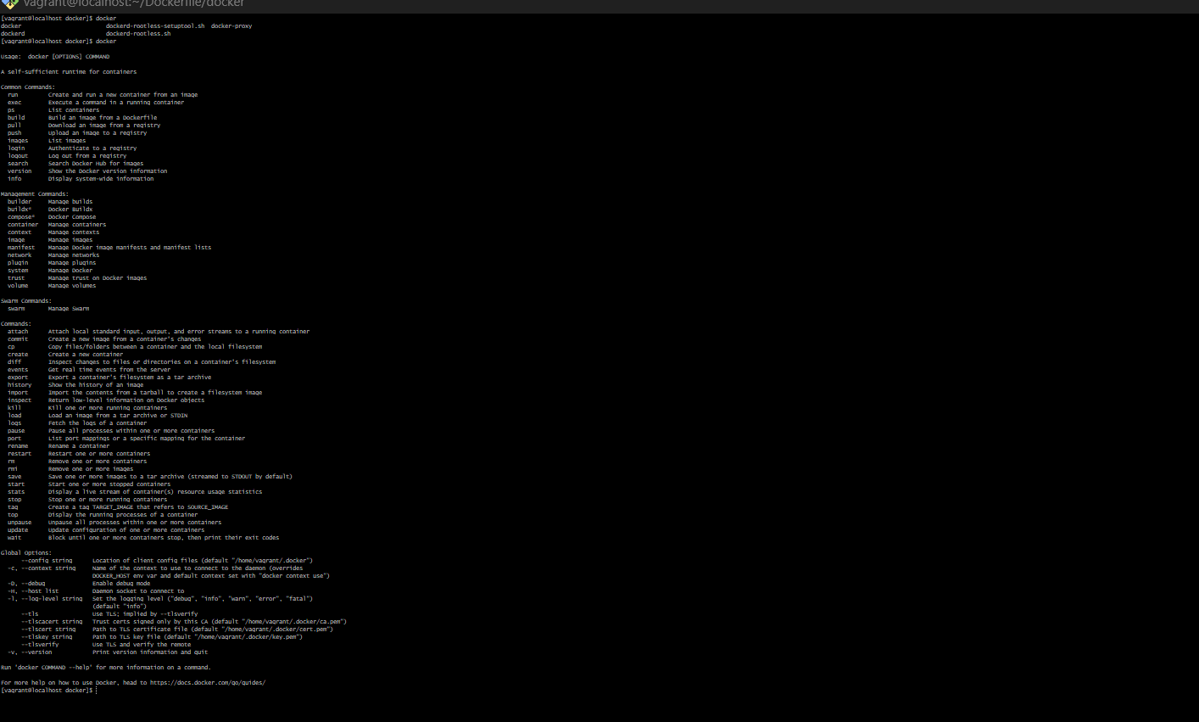

If we need to know about the list of image applicable in Docker we need to use the cml line called

* Sudo docker search <image name>

One we installed the docker we need to add the local user to docker group cml line below

* Chmod -aG docker <username>

Once its added we need to verify the group was added or not by using the cml line called

* Cat /etc/group

To build the image from the docker we need to use the cml line called

* Docker build -t <image name>
* And we can use the pull option from the docker existing image
* Docker pull <image name >

If we need to check the list of the docker was installed in the machine cml line we need to use

* Docker images
* 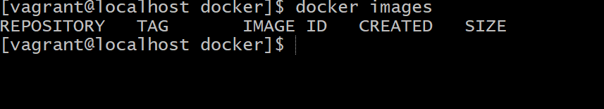

For list the container we need to use the cml line called

* Docker ps -a

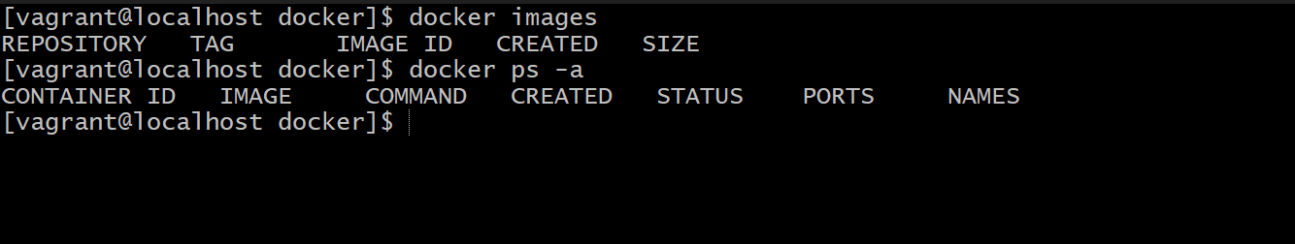

To remove the image/ container we need to use the cml line called

* Docker rm for container
* Docker rmi for image